**Bug ID:** 1

**Bug Summary:** ‘Forgot Password’ Function

**Environment:** Samsung S21 / One UI version 5.0

**Operation System:** Android version 13

**Version**: 1

**App:** Wattpad Beta

**Submit Date:** 12/01/2023

**Reporter:** Gayane Vardanyan

**Steps to Reproduce:**

1. Open the App Wattpad Beta
2. Log in via Google account (gayane.vardanyan.r@gmail.com)
3. Press settings button
4. Press Log Out
5. Press ‘Forgot Password’
6. Write email address ([gayane.vardanyan.r@gmail.com](mailto:gayane.vardanyan.r@gmail.com))
7. Press ‘Send instructions’

**Expected Result:** Send instructions

**Actual Result:** Appears message “User not found”.

**Screenshot/video:** Screenshot is attached

**Notes:**

**References:**

**Severity:** High

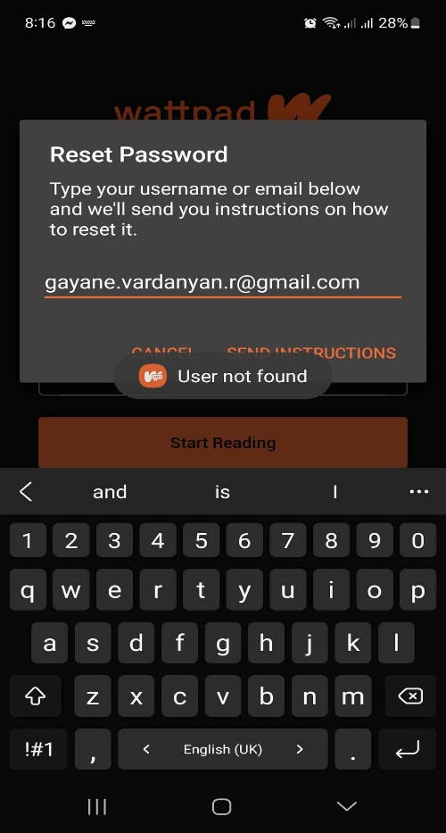

**Bug ID:** 2

**Bug Summary:** ‘New Account’ Function

**Environment:** Samsung S21 / One UI version 5.0

**Operation System:** Android version 13

**Version**: 1

**App:** Wattpad Beta

**Submit Date:** 12/01/2023

**Reporter:** Gayane Vardanyan

**Steps to Reproduce:**

1. Open the App Wattpad Beta
2. Press ‘Don’t have an account? Sign Up’ link
3. Enter email address ([gayane.vardanyan.r@gmail.com](mailto:gayane.vardanyan.r@gmail.com))

**Expected Result:** Create an account

**Actual Result:** Appears message “That email address is already registered”.

**Screenshot/video:** Screenshot is attached

**Notes:**

**References:**

**Severity:** High

